SUMMERVILLE CREDIT UNION · CONSOLIDATED MEMBER GUIDE · CSUM-12 of 30
Zelle® P2P Payments

Module: nFinia Digital Banking > Move Money > Zelle
Sources: Summerville Reports Series A (36 docs) + Series B (25 docs) | Features: nFinia Documentation Features Spreadsheet
01 PRODUCT SUMMARY

Zelle® is a real-time person-to-person (P2P) payment network integrated natively into the nFinia Move Money suite. It enables Summerville Credit Union members to send and receive money directly with friends, family, and other trusted individuals — regardless of where those recipients bank — in a matter of minutes, using only the recipient's U.S. mobile phone number or email address.
The Zelle® integration within nFinia means members do not need a separate Zelle app or account. Transactions flow directly between bank accounts without storing money in a digital wallet. Members can send money, request money from others, split bills across multiple people, and manage Zelle® activity and settings from within digital banking.
Because Zelle® payments to enrolled recipients are processed instantly and are effectively irreversible, members are strongly advised to verify the recipient's contact information before sending. Zelle® is intended for payments between people who know and trust each other.

At a Glance

Attribute | Detail
Module | Move Money > Zelle®
Network | Zelle® P2P Payment Network
Recipient Identifier | US mobile phone number or email address
Transfer Speed | Minutes to enrolled recipients; 14-day window for unenrolled
Reversibility | Cannot be cancelled once recipient is enrolled in Zelle
Related Reports | CSUM-06 (Move Money Hub), CSUM-09 (External ACH)

02 KEY USE CASES

Use Case | Who Uses It | What They Do | Business Value
Split Bill | Members splitting a restaurant or shared bill | Send the exact share to each recipient's enrolled Zelle contact | Eliminates cash exchange for shared expenses
Pay an Individual | Members paying a trusted person | Enter recipient phone/email, amount, note, and send | Works for babysitters, tutors, contractors, friends, and family
Request Money | Members asking someone to pay them back | Use Zelle Request to send a payment request to a contact | Recipient receives notification and can pay instantly via Zelle
Receive Payment | Members expecting funds from another Zelle user | Share your enrolled phone number or email for others to send to you | Funds arrive directly into linked CU checking account

03 STEP-BY-STEP GUIDE

Navigation: Dashboard > Move Money > 'Zelle'.

Step 1 — Start from Dashboard
The member begins at the Dashboard after logging in. The Dashboard displays all account balances, upcoming payments, quick-action tiles, and the top navigation bar with links to Accounts, Move Money, and More.
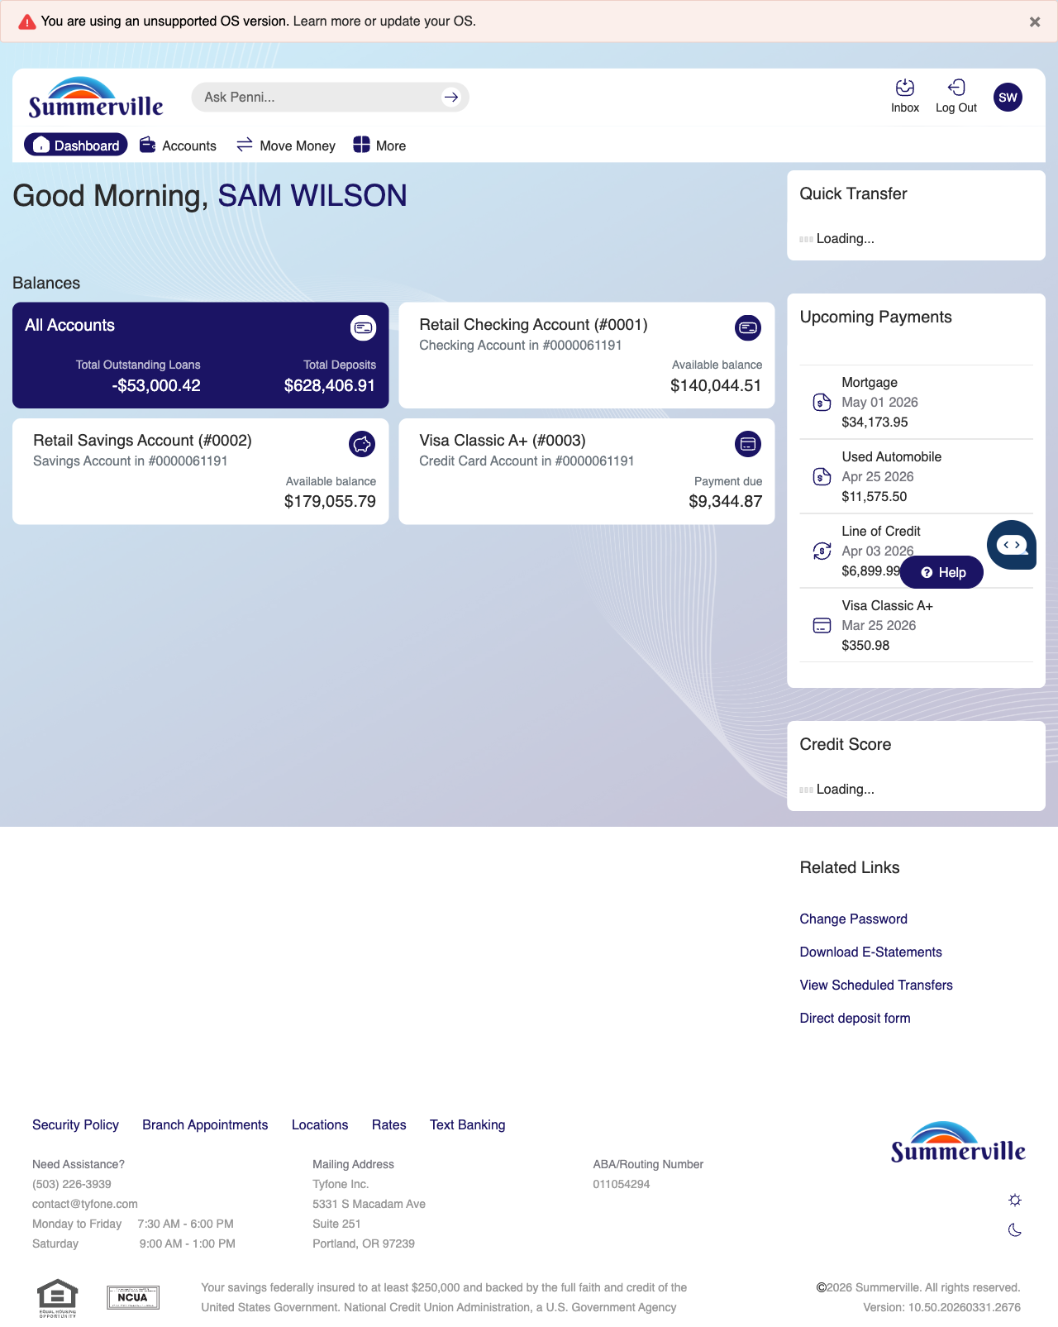
Step 1: Start from Dashboard

Step 2 — Navigate to Move Money Hub
The member clicks ‘Move Money’ in the top navigation bar. The Move Money Hub displays all payment and transfer options as tiles including Pay Bills, Quick Pay, Zelle Payment, Internal Transfers, Other Members, Same-Day Transfers, Send Instantly, Manage Recipients, Add Recipient, Transaction History, Scheduled Transfers, and P2P Transfer.
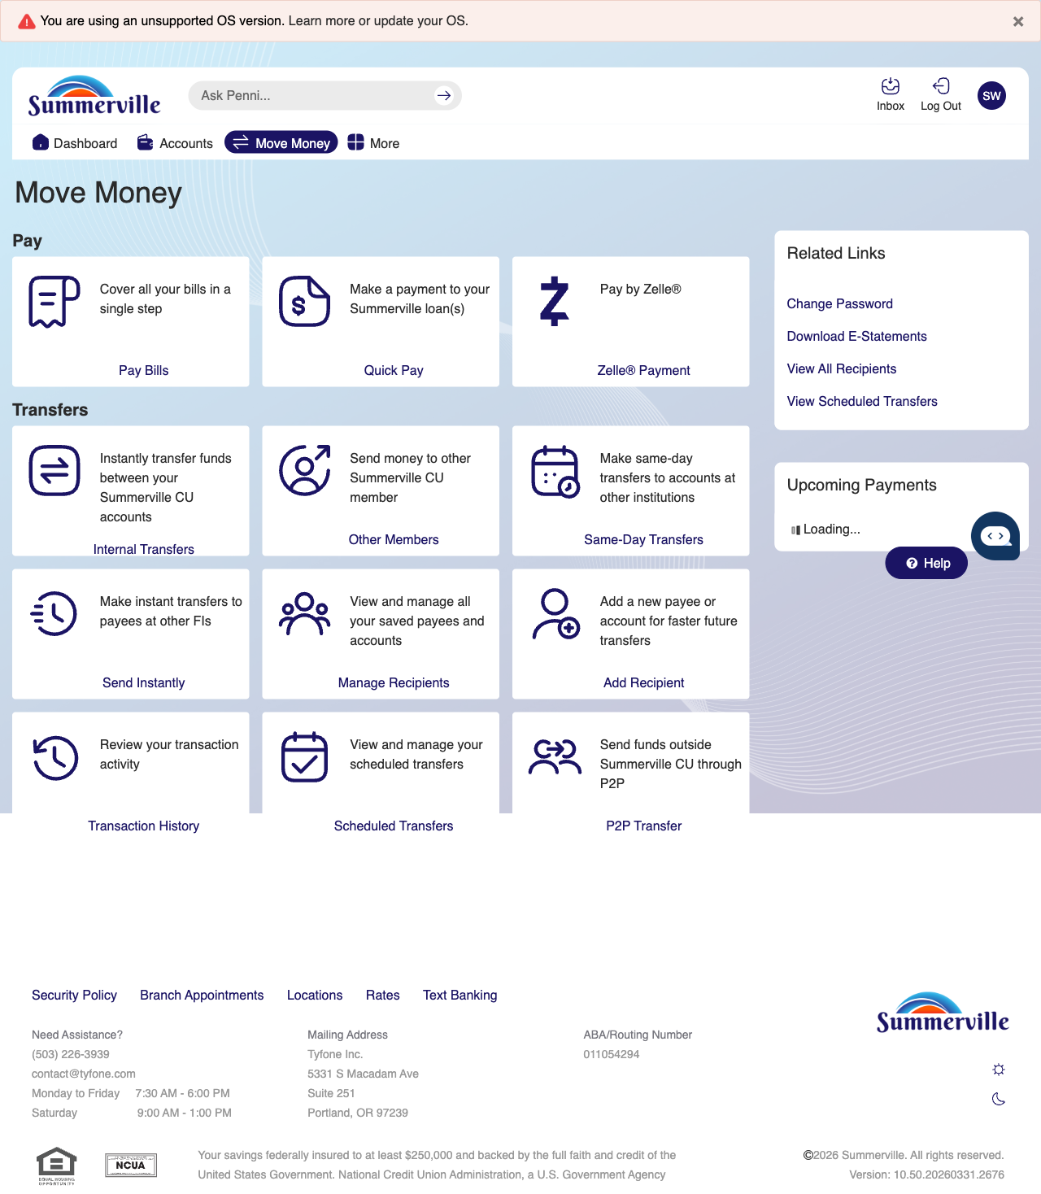
Step 2: Move Money Hub

Step 3 — Navigate from Dashboard to Zelle
The Move Money hub is shown with payment options including Pay Bills, Quick Pay, Zelle Payment, and various transfer services available as tiles.

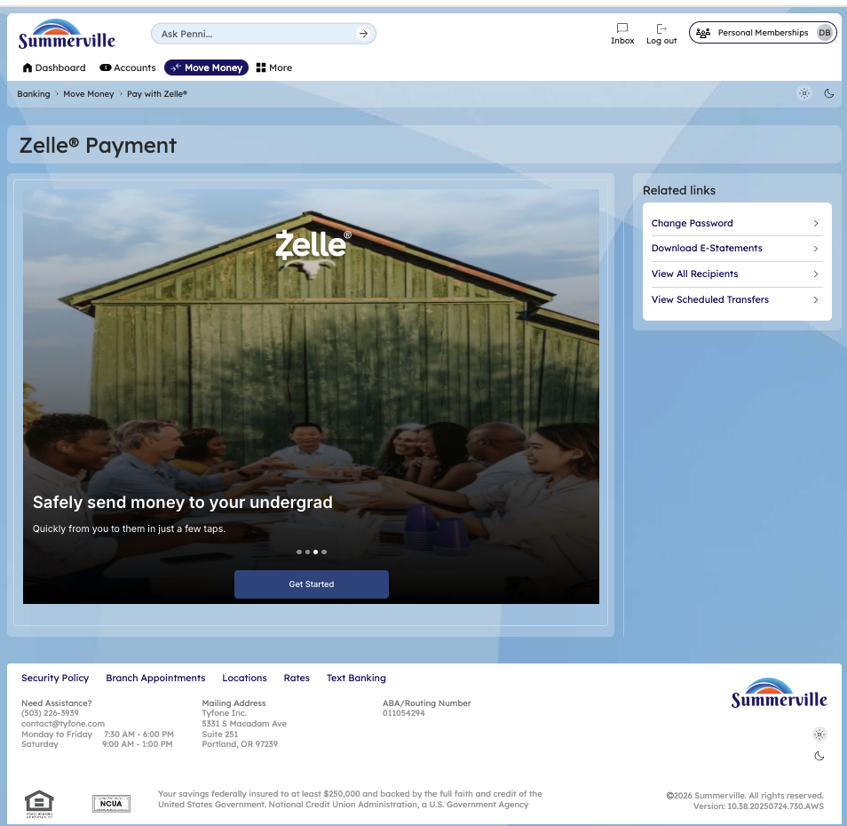

Step 4 — Send a Zelle Payment
The Zelle Payment form page is displayed from a legacy banking interface with form fields visible for entering recipient and payment details.
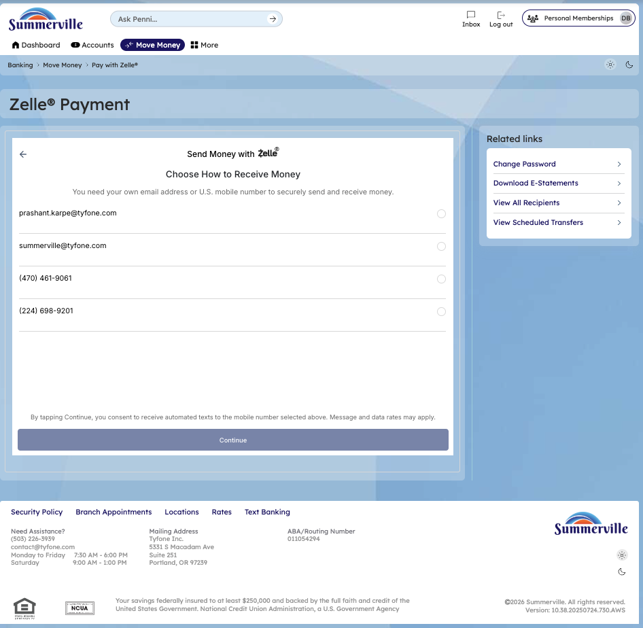

Step 5 — Verify Zelle Payment
The Zelle verification screen prompts the member to enter a 6-digit verification code sent via SMS to verify and complete the Zelle transaction.
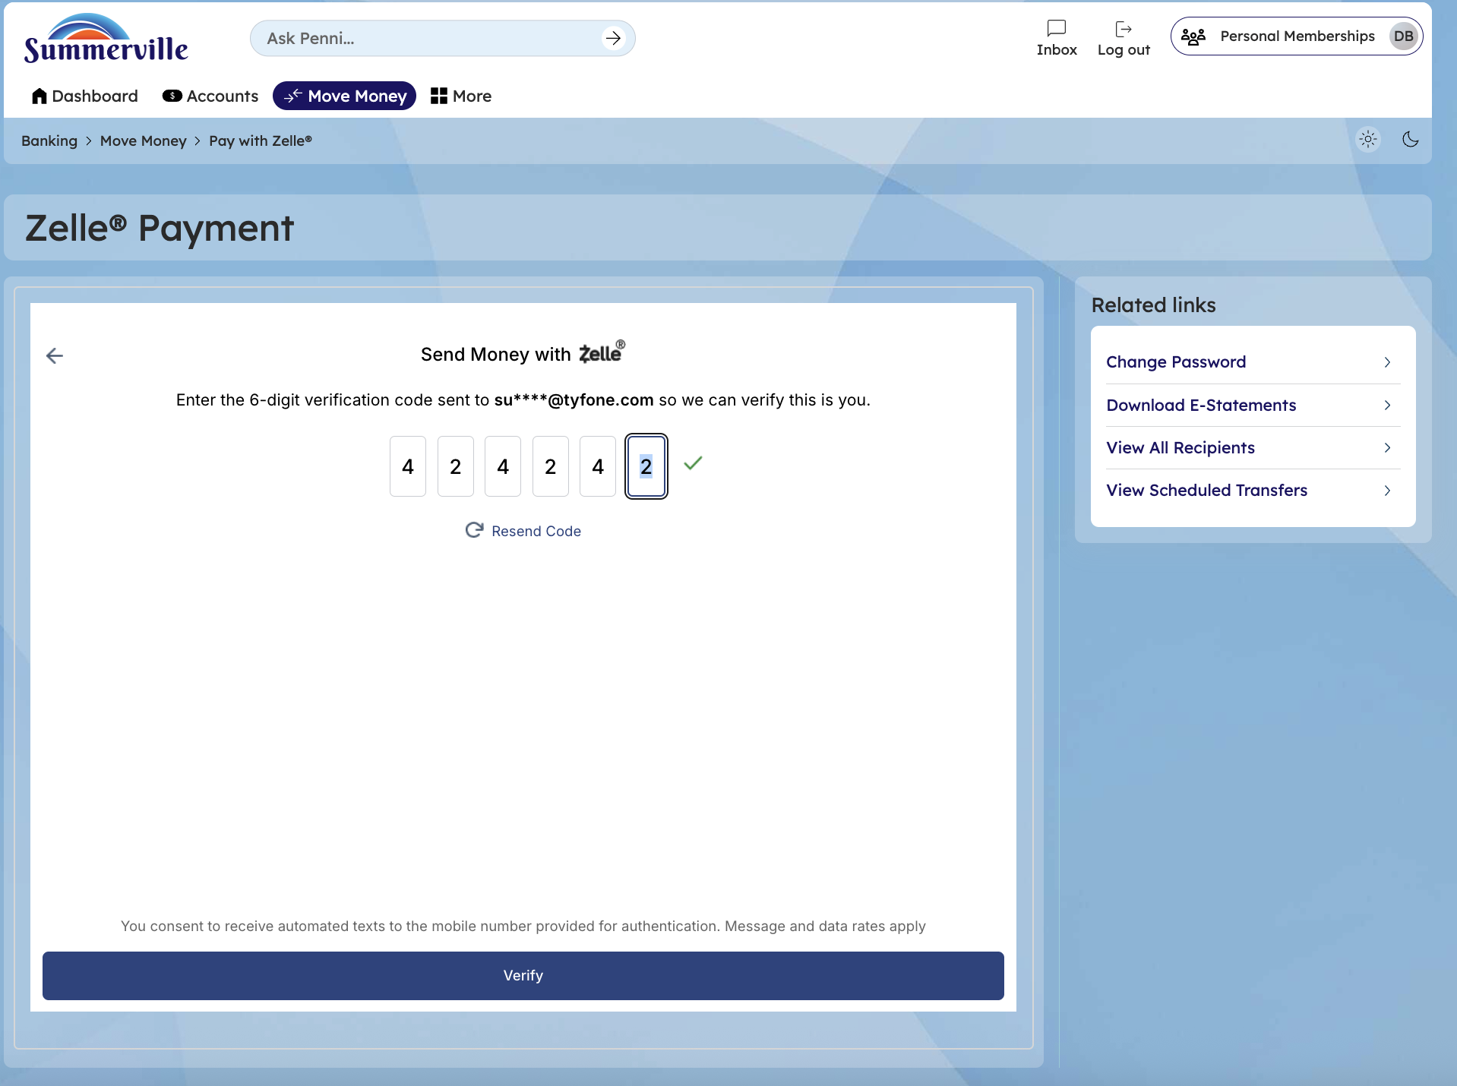
Step 5: Verify Zelle Payment

